**BOOK ONE-WAY OUTSTATION CAB & DISPLAY THE LOWEST CHARGES**

Software Requirements Specification

|  |  |  |  |
| --- | --- | --- | --- |
|  | Prepared By | Reviewed By | Approved By |
| Name | Wanderers | Devathilagai |  |
| Role | Interns | Batch Trainer |  |

**Table of Contents**

Table of Contents…………………………………………………………..….......II

1. Introduction…………………………………………………………………..…1

1.1 Intended Audience……………………………………………….......1

1.2 Project Scope…………………………...……………………………1

2. Overall Description…………………………………………….……………….1

2.1 Operating Environment……………………...……………………....1

3. Requirements……………………………………………………………...…….1

3.1Login………………………………………………………………….2

3.1.1Description………………………………………………....2

3.1.2 Functional Requirements……..…………………………...2

**1. Introduction**

MakeMyTrip is an [Indian](https://en.wikipedia.org/wiki/List_of_companies_of_India) online travel company founded in 2000. Headquartered in [Gurugram](https://en.wikipedia.org/wiki/Gurgaon), [Haryana](https://en.wikipedia.org/wiki/Haryana), the company provides online travel services including [airline tickets](https://en.wikipedia.org/wiki/Airline_ticket), domestic and international holiday packages, [hotel](https://en.wikipedia.org/wiki/Hotel) reservations, [rail](https://en.wikipedia.org/wiki/Rail_transport), and [bus](https://en.wikipedia.org/wiki/Bus) tickets.

**1.1 Intended Audience**

Business Unit (BU) SME

Academy coach

Technical Trainer

**1.2 Project Scope**

This document defines at a functional level the business activities that are encompassed by the system and the rules that apply to them. It also encompasses some of the key high and low level technical requirements of the system.

It draws heavily on both proposed Framework and Business Rules and the Technical Architecture documents. The scope of the detailed analysis project phase specifies that this document will include.

· Classification of requirements according to their functional areas.

· A description of each process in the system, including their inputs, outputs, and data transformation rules.

**2. Overall Description**

**2.1 Operating Environment**

Windows operating system

Web application

**3. Requirements**

This part of the requirements document serves Flight Booking from one place to another place, Hotel Booking, Cab Booking, Train Booking, Bus Booking and Presenting Giftcards using the application “MakeMyTrip”.

**3.1.1 Functional Requirements**

**3.1.1.1 Req0001**

**Req0001a-**The user selects “Cab” option from Menu list and Selects “Outstation One way” from Trip type.

**Req0001b**-The user Enter details like “From” location as “Delhi”, “To” location as “Manali”, “Pick-up Date” and “Pick-up Time” and then clicks on “Search”.

**Req0001c-**The user selects “SUV” from “Cab-type”.

**Req0001d**- The user have to check for the Lowest price of Cab.

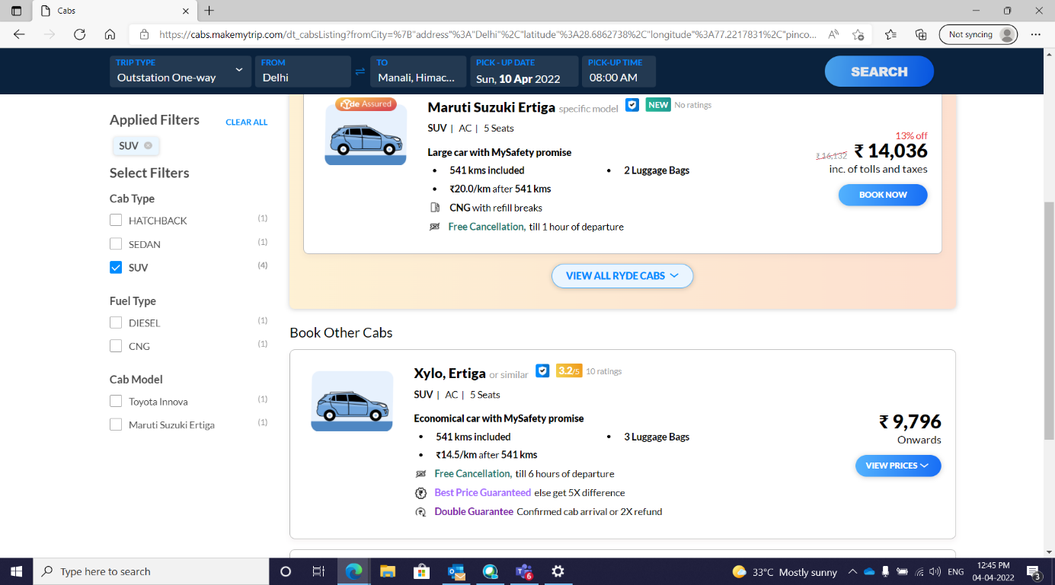

**3.1.1.2 Req0002**

**Req0002a**- The user selects “Activities” option from Menu list and then selects “More” option.

**Req0002b-** The user clicks on “Giftcards”. Then he selects “Corporate” from “Category”.

**Req0002c-** The user fills all the Details and give invalid E-mail id.

**Req0002d**- The user clicks on “Buy now”.

**Req0002e**- Error message will be displayed.

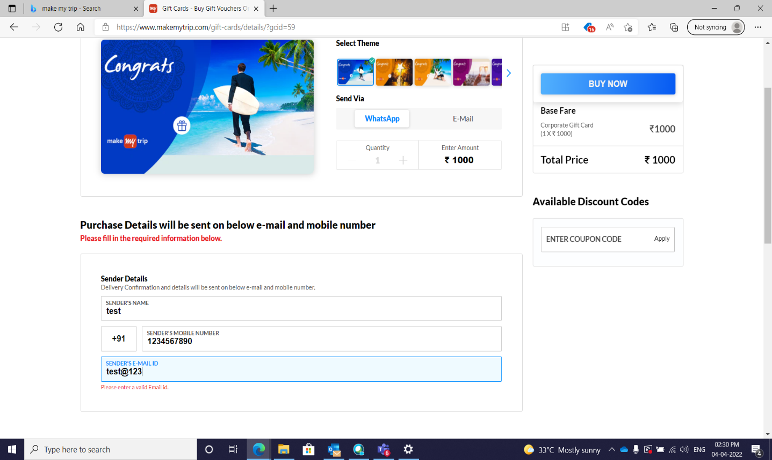

**3.1.2.3 Req0003**

**Req0003a**- The user selects “Hotels” from Menu list.

**Req0003b-** The user enters details like “Hotel Area” as “Manali”, “Check-in”, “Check-out”.

**Req0003c-** The user clicks on “Rooms & Guests” and checks the number of Adult person.

